Enhanced Detection of Network Anomalies Using a Hybrid Artificial Neural Network and Convolutional Neural Network Model

Dogiparthi Harini¹, Dogiparthi Aasrith², Kalla Bharath Vardhan³, Varanasi Sai Charan⁴, Bhavadharini R.M^{5*}
^{1,2,3,4} School of Computer Science and Engineering,
Vellore Institute of Technology,
Chennai, Tamilnadu, India
[e-mail: dogiparthi.harini2022@vitstudent.ac.in, dogiparthi.aasrith2021@vitstudent.ac.in, kallabharathvardhan.2021@vitstudent.ac.in, varanasisai.charan2021@vitstudent.ac.in, bhavadharini.rm@vit.ac.in]
*Corresponding author: Bhavadharini.R.M

Abstract

Network traffic faces several challenges and issues in maintaining data interception to ensure confidentiality, integrity, and authenticity of communication. However, it possesses severe threats from malicious ones, such as data exfiltration, Distributed Denial-of-Service (DDoS) attacks, and command-and-control operations by cybercriminals. The inability to directly inspect payloads complicates network anomaly detection, leaving security systems to rely on indirect features like packet metadata and flow patterns, which are often insufficient to comprehensively identify sophisticated threats. Traditional anomaly detection methods, such as deep packet inspection and rule-based systems, are increasingly rendered ineffective in encrypted environments. Deep packet inspection requires decryption, which is computationally expensive, violates privacy regulations, and introduces latency into the network. Similarly, rule-based systems rely heavily on predefined signatures and heuristics, which fail to adapt to emerging threats or detect zero-day anomalies. These approaches create significant gaps in security, especially as network traffic continues to grow in volume and complexity across various industries. To address these challenges, a hybrid model of Artificial Neural Network (ANN) and Convolutional Neural Network (CNN) model is proposed. The hybrid model achieves 98.34% accuracy, with precision of 92.5%, recall of 96.5% and F1-score of 95.5% respectively while standalone ANN model resulted with 96.82% accuracy, and CNN model showed 94.36%. Comparatively, the hybrid system results in more accuracy and is more efficient than individual ANN and CNN models.

Keywords: Network traffic anomaly, Artificial Neural Network (ANN), Convolutional Neural Network (CNN), Hybrid model
1. Introduction
The widespread adoption of communication protocols, such as Internet Control Message Protocol (ICMP), User Datagram Protocol (UDP) and Transmission Control Protocol (TCP), has significantly enhanced data security and privacy in digital networks. These protocols ensure that sensitive information remains confidential, making them integral to modern communication systems. Advanced machine learning techniques have emerged as promising solutions, leveraging metadata and statistical features to detect deviations indicative of malicious activities. However, existing models often face limitations such as high computational costs, overfitting on imbalanced datasets, and difficulty in adapting to evolving threats [1]. These limitations underscore the need for robust, scalable, and privacy-preserving solutions capable of maintaining high detection accuracy without decrypting the traffic. The challenge is further exacerbated by the need to balance privacy preservation with effective threat detection. While network traffic protects user's sensitive data, it also hinders the ability to monitor network activity, creating a blind spot for security solutions [4]. This trade-off necessitates the development of innovative approaches that can accurately detect anomalies without decrypting traffic. Achieving this balance requires a paradigm shift from traditional techniques to advanced machine learning-based models capable of leveraging network traffic metadata to identify malicious behaviors with minimal computational overhead and high accuracy.
This study proposes a hybrid anomaly detection system that combines ANN and CNN with custom enhancements to address these challenges. By incorporating advanced activation functions, such as Swish and GELU, which improve non-linearity handling and gradient flow, resulting in better generalization and performance. These functions allow for smoother convergence and better generalization, leading to superior performance compared to standard activation techniques like ReLU or Sigmoid. The hybrid architecture, designed to optimize feature learning and classification accuracy, demonstrates significant potential for anomaly detection in network traffic. This approach enhances detection capabilities, allowing it a viable solution for modern cybersecurity landscapes.
The primary research objective is to develop a resilient hybrid anomaly detection system by merging Artificial Neural Networks (ANNs) with customized improvements which solve encryption traffic-specific problems. The specific goals are:
- Integration of Advanced Activation Functions: Incorporating advanced activation functions such as Swish or GELU to improve the learning process and increase model efficiency in detecting anomalies.

- Efficient Feature Learning: Optimizing feature extraction and selection to improve detection capabilities without the need for decrypting traffic, thereby maintaining privacy and security.

2. Literature Review
Anomaly detection methods that rely on inspecting packet contents become less effective since encrypted network traffic usage steadily increases. Wu, Z et al. [1] presented an extensive analysis of advanced methodologies which solve the problems of encrypted traffic anomaly detection. They proposed a semi-supervised anomaly detection framework Poison-Resistant Anomaly Detection (PRAD operates to defend against poisoning attacks as well as reduce human labeling mistakes. Xing, J. et al.,[2] performed an online clustering approach that forms the basis of anomaly detection to increase detection reliability. The deep dictionary learning with Long short-term memory (LSTM)-based autoencoder forms the basis of D2LAD which operates as a completely unsupervised online anomaly detection system. D2LAD shows high performance across real-world benchmarks through experiments which prove its ability to successfully detect anomalies with low resource requirements. In [3], Behdadnia, T. et al., employed a detection method that produced 93% successful results in abnormal traffic identification which demonstrates its usefulness for anomaly detection systems in power grid communication networks. Yu, T. et al.,[4] and Lv, G. et al.,[5] discussed how the combination of methods strengthens critical infrastructure cybersecurity because attacks get discovered. Through sandbox-based process data collection, users can identify standard traffic along with their malicious counterparts. Labeling features run sequentially through multiple Auto Encoder(AE) layers that create expanded dimensional vectors to enhance classification quality. Experimental results demonstrate that the multi-AE system outperforms traditional models by reaching better accuracy rates with lower loss numbers. Kopp, M. et al.,[6] and Han, S. et al.,[7] also investigated dataset imbalance effects which show that unbalanced conditions reduce positive detection success. A new classification system used a two-step randomized forest procedural approach which features modified random forest elements. The evaluation with ISCX VPN-NonVPN data demonstrated that multi-AE achieves better classification results than standard approaches by showing 5% increased accuracy since decision trees and KNN and general random forest algorithms were tested. By integrating this approach, the precision of traffic classification gets better during the time encrypted traffic prevails over the Internet.
Shen, M. et al.,[8] and Meghdouri, F. et al.,[9] proposed an unsupervised procedure to detect zero-day DDoS attacks against IoT networks through random projection and ensemble models of K-means, GMM (Gaussian Mixture Model), and one-class SVM which reached 94.55% accuracy. The authors applied deep convolutional autoencoder (MR-DCAE) using manifold regularization to detect unauthorized broadcasting through their model for feature compression autoencoders in research. In terms of machine learning framework, Wang, Z. et al.,[10] and Zhu, Z. et al.,[11] discussed a generic FL-based anomaly detection framework for energy theft detection, where each user used their private electricity usage data to train local deep autoencoder-based detectors. The authors Ucci, D. et al.,[12] and Kim, M. G. et al.,[13] reported numerous academic investigations that took place in malware attack detection together with network traffic anomaly detection and related areas. An anomaly detection research team developed a reconstruction error-based system utilizing an autoencoder (AE) for packet metadata anal2ysis without particular node information and demonstrated superior performance over conventional approaches with improved accuracy and AUC score and precision rates and F1 scores. Ashraf, J. et al.,[14] and Long, G. et al.,[15] provided a complete review of machine learning-based models for detecting encrypted malicious traffic, together with a framework for systematic debate and analysis of these models. Multiple machine learning algorithms such as decision trees, random forests and gradient boosting and SVM and neural networks operate in identity resolution to enhance data quality and automatic resolution processes and dynamic data management. The field of encrypted traffic detection and sophisticated cyber-attack modeling depends on advanced detection methods alongside machine learning models. Pratiwi, M. et al.,[16] discussed about the growing concern about adversarial attacks, especially ransomware attacks, which can alter training data to impair model performance during model training. Researchers have examined the effects of these attacks on various machine learning models and classified them according to their goals. Tian, Z. et al.,[17] discussed that strong training mechanisms, anomaly detection in training data, and safe aggregation methods for federated learning are some of the countermeasures that have been suggested for poisoning attacks. Anderson, B. et al.,[18] showcased that, in certain situations, supervised machine learning models that have been trained on huge datasets have demonstrated promise in reaching 0% false discovery rates. Shekhawat, A. S. et al.,[19] and Velan, P. et al.,[20] discussed that feature selection is now being automated using machine learning models to identify subtle patterns indicative of malicious activity. Payload-based and feature-based categorization algorithms are distinguished in surveys; the latter is becoming more popular because it is independent of protocols. The trade-offs between accuracy, processing cost, and adaptability to shifting network environments are highlighted in thorough studies.
Rezaei, S. et al.,[21] and Wang, J. et al.,[22] state that, Traffic classification has developed over the course of two decades and has been instrumental in applications including Quality of Service (QoS) provisioning and billing, as well as security enforcement in firewalls and intrusion detection systems. The traditional approaches like port-based analysis, packet inspection, and machine learning techniques have found it difficult to deal with the growing dominance of encrypted traffic, paving the way for moving toward deep learning-based methods. Recent work of Wingarz, T. et al.,[23] emphasized on deep learning models such as CNNs, LSTM, and Gated Recurrent Units (GRUs) as the potential solutions to anomaly detection from encrypted traffic due to their potential to learn complex patterns without human intervention in selecting features. Bakhshi, T. et al.,[24] and Lee, I. et al.,[25] deployed hybrid architectures, and CNN-GRU has proved superior to other hybrids by combining effective feature extraction and incremental learning of temporal patterns. Models such as Deep Encrypted Traffic Detection (DETD) and autoencoder-based methods have also shown significant improvement in the accuracy of anomaly detection and effectiveness of feature extraction. Moreover, incremental machine learning methods like SVM with Stochastic Gradient Descent (SGD) have been introduced for encrypted malware detection, with adaptability via periodic updates. Baldoni, S. et al,[27] stated that network of interconnected devices has widened the threat area to network, which requires proper anomaly detection. Standard supervised-IDSs have problems in training and flexibility to label the data. Unsupervised algorithm such as PCA has low complexity, real-time detection algorithm that does not require huge training sets. Recent research works demonstrated that PCA classifies normal and anomalous traffic based on compact network summaries in an effective way. Nwatuzie, G. et al,[28] emphasized that, ensuring data consistency in network monitoring is important as hardware failures, and attack take place. Anomaly detectors on traditional systems are poor in dealing with either missing or corrupt data. Dynamic recovery and real-time detection were made possible with the support of machine learning models such as LSTM, GRU and Autoencoders. The techniques are more accurate, scalable and efficient in supporting large scale contemporary networks. Ness, S. et al,[29] discussed that the learning of machines is a usual activity on robust anomalous detection of complex network traffic. Due to a high level of accuracy, models such as XGBoost, LightGBM, and SVM have a good performance, and Isolation Forest is not satisfactory. Both Supervised and unsupervised methods embrace complications of imbalance in the class and the complexity of feature. The real-world applications of cybersecurity are enhanced in accuracy and scalability through such methods.
Gassaloglu, Y. et al,[30] examined that, Next-Generation Firewalls (NGFWs) are also improved with machine learning as a way to overcome the flaws of older firewalls in coping with more advanced cyber-attacks. The supervised models such as SVM, Random Forest and KNN and unsupervised models such as Isolation forest and K-means have been found to be more accurate and also have lower false positives on the NSL-KDD dataset. Such models are dynamic flexible in environments. The incorporation of ML enables NGFWs to identify the unknown and known threats effectively. Khan, M. M. et al,[31] stated that, Signature-based IDS can not detect the uncharacterized cyber-attacks, as much as Anomaly-based Intrusion Detection System ( IDS ) does. Natural ML models such as KNN, Naive Bayes, Logistic Regression, Decision Trees as well as SVM have demonstrated varied results. Such models can be augmented by ensemble learning, especially the use of stacking classifiers, to increase accuracy of detection. Research papers on NSL-KDD and Kaggle dataset show that with ensemble methods, the precision, recall, and precipitated overall detection increase dramatically. Ji, C. et al,[32] emphasized on, current signature-based intrusion detection systems have trouble in identifying unknown and highly advanced attacks. Although ML algorithms, such as SVM and KNN, showed better accuracy, they are having issues with scalability and manual feature extraction. The deep learning models provide automation of feature extraction yet still seems to be impractical with a high rate of false positives. Present studies fill these gaps by using hybrid models to achieve improved anomaly detection in the complex network traffic by using residual networks, attention mechanisms, and recurrent units.
Rao, V. S. et al,[33] proposed a hybrid CNN-GAN model to overcome the shortcoming of the traditional anomaly detection method of detecting new cyber threats. CNNs learn complex traffic patterns and GANs create synthetic normal dataset in order to improve on generalization. The combination will increase the accuracy in the detection and fewer false positives are produced. Simulation results indicate that the model performs better than the current systems on real-time network security settings. PM, V. P. et al,[34] discussed about the increase in the complexity of network traffic and cyber threats has made the anomaly detection process with AI/ML, such as using CNNs or RNNs, to be effective than using rule-based systems. Although supervised, unsupervised, and deep learning models deliver high accuracy, there are data quality issues, heavy backloads, and explainability. Intelligent computing will be able to enhance detection and will have to be constantly improved to ensure that it translates to defense against changing threats. Koumar, J. et al,[35] emphasizes, The key to detecting anomalies in network traffic is precise detection to identify these threats, whereas the available real-world data in terms of traffic is limited and cannot assess the algorithms efficiently. To overcome this problem, the researchers provided the CESNET-TimeSeries24 traced set (40 weeks of ISP trafic) to more than 275,000 IP addresses. These realistic, high-density data allow more thorough testing of detection models based on forecasting. Liu, D. et al,[36] pointed out that, Photovoltaic (PV) systems heavily depend on networks which are vulnerable, thus making anomaly detection extremely crucial. Subtle threats, such as a DDoS attack and surge traffic, are usually overlooked by traditional means. Examples of security frameworks to improve the reliability and avoid data breach include PCFT and NQA. These developments underscore the increasing role of deep learning and adaptive techniques of machine learning in confronting the difficulties created by encrypted traffic in today's cybersecurity and network management. Table 1 shows the comparison of performance parameters of the referenced results.

Table 1. Comparison of Results achieved in Various Machine Learning and Deep Learning Models

Authors | Models | Results | Dataset
Wu, Z., .et al (2024) [1] | Variational Recurrent Neural Network | Accuracy-85.2% | CTU13 and CIRA-CIC-DoHBrw
Xing, J., et al (2020) [2] | LSTM-based Autoencoder | Accuracy-94.5% | CTU-13
Yu, T., .et al (2019) [4] | Autoencoder | Accuracy-96.3% | Self-created
Lv, G., et al. (2020) [5] | Decision tree, KNN, Random Forest | Accuracy in  Decision tree-71%,  KNN-67.47%, Random Forset-73.46% | ISCX VPN-NonVPN
Kopp, M., et al (2018) [6] | Clustering | Threshold-95% | NetFlow
Han, S., et al (2022) [7] | K Means, SVM, XGBoost, LSTM | Accuracy in  K Means-93%, SVM-88%, XGBoost-88%, LSTM-88% | DataCon2020
Shen, M., et al (2022) [8] | Decision Tree, Random Forest, LSTM | Accuracy in  Decision Tree-97%, Random Forest-96%, LSTM-98% | YouTube and Bilibili
Meghdouri, F., et al (2020) [9] | Random Forest | Accuracy in  CICIDS2017-99%, UNSW-NB15-99.4%,  ISCX-Bot-2014-99.7% | CICIDS2017, UNSW-NB15, ISCX-Bot-2014
Wang, Z., et al (2022) [10] | Convolutional Autoencoders | Accuracy-87% | CICIDS2017
Zhu, Z., et al (2022) [11] | Random Forest, CNN, LeNet-5 | Recall  Random Forest-85%, CNN-100%, LeNet-5-99.49% | HANDLE2022
Kim, M. G., et al (2024) [13] | Isolation Forest, OneClassSVM,  Auto Encoder | Accuracy in  IsolationForest-85.4%, OneClassSVM-73.9%, Auto Encoder-85.6% | CICIoT2023
Long, G., et al (2023) [15] | Conventional Stacked Autoencoder | Accuracy-96.98 | CTU-13
Pratiwi, M. et al (2024) [16] | LSTM | Accuracy-99.37% | Self-created
Anderson, B., et al (2016) [18] | l1-logistic regression | Accuracy-93.978% | Self-created
Shekhawat, A. S., et al (2019) [19] | SVM, Random Forest, XGBoost | Accuracy in  SVM-92%, Random Forest- 96.80%, XGBoost- 97% | CTU-13
Wingarz, T., et al (2024) [23] | ANN, SVM | Accuracy in  ANN-82%, SVM-91% | CSE-CIC-IDS2018
Bakhshi, T., et al (2021) [24] | Hybrid: CNN+GRU | Accuracy in  NSL-KDD-93.10%  NB15-91.21%,  CIC-17-90.17% | NSL-KDD, UNSW-NB15, andCIC-IDS-2017
Lee, I., Roh, H., et al (2021) [25] | Stochastic Gradient Descent, Passive Aggressive, Gaussian Naive Bayes | Accuracy  Stochastic Gradient Descent-94.4%, Passive Aggressive-86.6%, Gaussian Naive Bayes-86% | Malware traffic analysis
Ness, S., Eswarakrishnan, V. et al, (2025) [29] | Random Forest, Naive Bayes, XGBoost, and SVM | Accuracy  Random Forest-82%  Naive Bayes-81%  XGBoost-83%  SVM-85% | KDDCup’99
Gassaloglu, Y, (2025) [30] | SVM, KNN, Random Forest | Accuracy  SVM-97%  KNN-98%  Random Forest- 98.7% | NSL-KDD
Khan, M. M., Rehman, M. (2024) [31] | KNN, SVM, Naïve Bayes, Logistic Regression | Accuracy  KNN-98.05%  SVM-58.90%  Naïve Bayes-85.06%  Logistic Regression-88.15% | ICSX 2012
Rao, V. S., Balakrishna, R., (2024) [33] | SVM, DNN | Accuracy  SVM-80.22%  DNN- 72.28% | NSL-KDD
Liu, D., Wang, S., et al, (2025) [36] | CNN | Accuracy  CNN-97% | PV Cell

3. Proposed Methodology
2.1 Dataset Description

The dataset, Network Intrusion Detection [26] from kaggle, includes different simulated intrusions that were conducted in a military network environment. The LAN was subjected to a simulated real-world scenario and faced various attacks. A connection is a series of TCP packets that start and end at a specific time interval, during which data is transmitted from a source IP address to a target IP address using a well-defined protocol. Furthermore, each link is categorized as either normal or an attack, with only one distinct type of attack. Each link record is approximately 100 kilobytes in size. Table 2 displays the total number of records in the dataset, which is 25212. The dataset is divided into training and test data in the ration of 80:20.

The normal and anomaly traffic data consist of 41 parameters, both quantitative and qualitative, for each TCP/IP connection (3 qualitative and 38 quantitative). The class variable has two categories as shown in Fig.1:
- Normal [53.4%]
- Anomaly [46.6%]

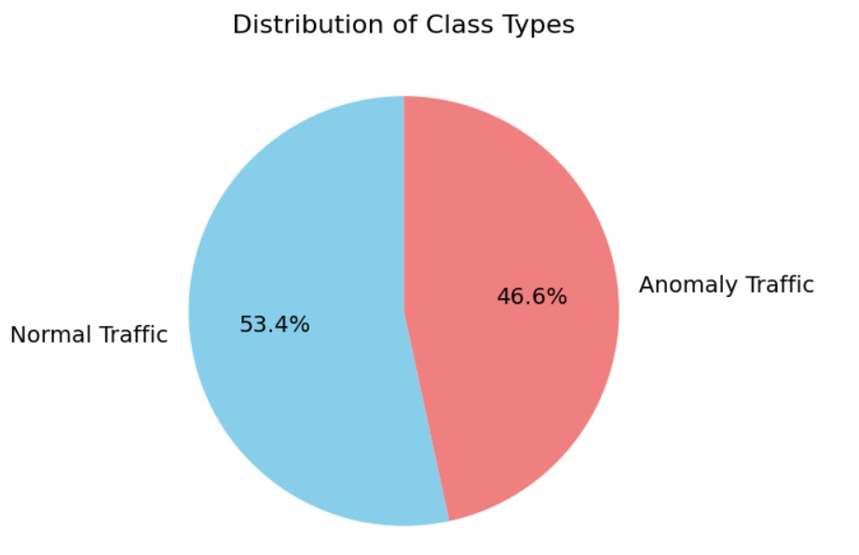
Fig. 1. Class Distribution in the dataset

Table 2. Dataset Description
Data Split | Classes | Count
Train | Normal | 10780
 | Anomaly | 9395
Test | Normal | 2689
 | Anomaly | 2348
Total |  | 25212

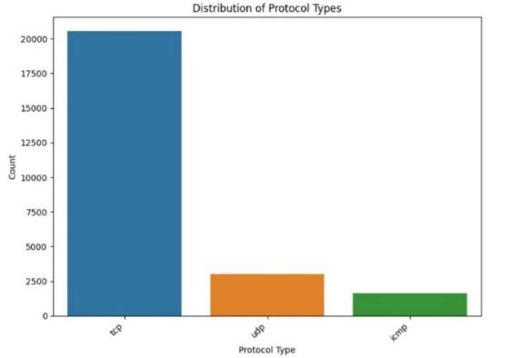
Fig. 2. Various Network Protocols in the dataset
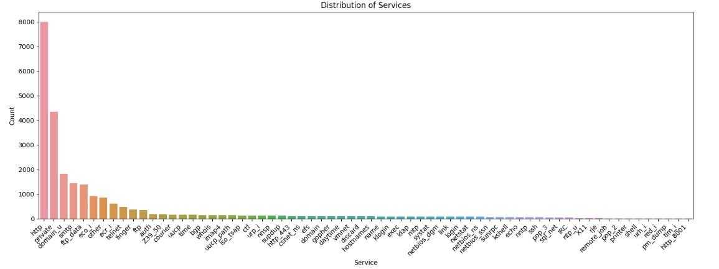
Fig. 3. Services in the dataset

Fig.2, shows all the protocols mentioned in the dataset and Fig.3 shows us all the services that are considered in the dataset. Fig. 4 shows how a hybrid deep learning model employs CNNs together with ANNs for classification purpose. Data Preprocessing (Module-1) includes the process data cleaning followed by splitting and extracting features to make the dataset ready. The preprocessed dataset enters CNN and ANN models simultaneously for the training phase. The model evaluation takes place after its training phase as part of the testing process. The proposed system generates outputs that classify each instance as either "Anomaly" or "Normal."

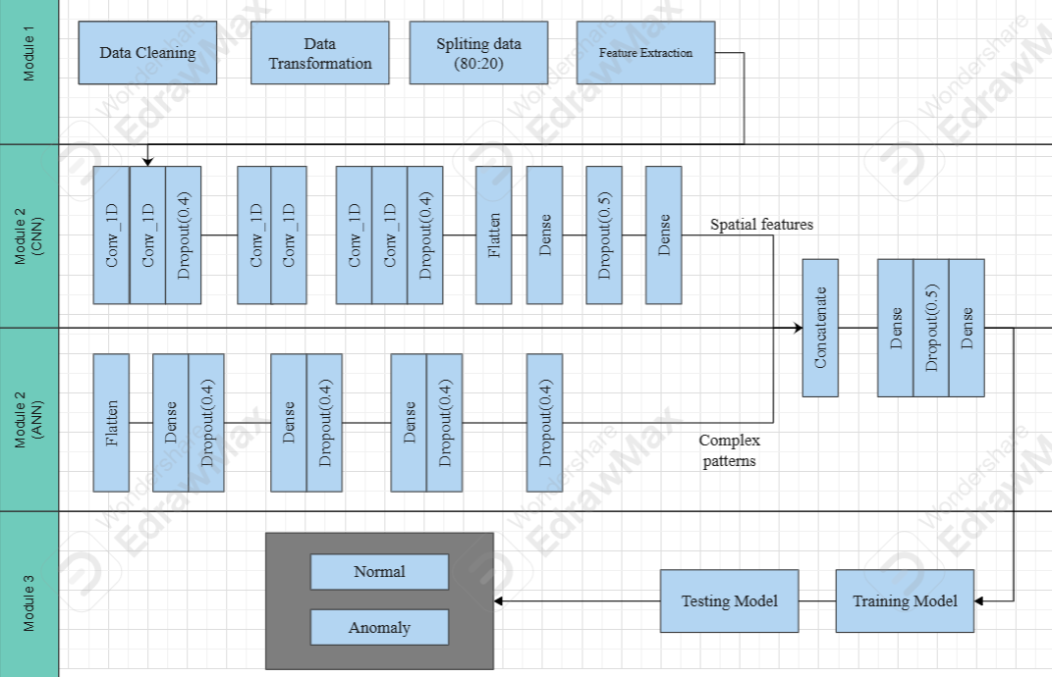
Fig. 4. System Architecture
2.2 Data Preprocessing
Data preprocessing is responsible for cleaning and preparing raw network traffic data from dataset: Network Intrusion Detection [26] for effective model training. It involves handling values which are missing, and performing feature extraction to ensure that the dataset is optimized for analysis. Label-encoding was performed for protocol_type, service, flag and class columns to change categorical values to numerical values. Additionally, SMOTE(Synthetic Minority Over-sampling Technique) technique was used to address class imbalance as shown in Fig.5. SMOTE generates synthetic minority class samples by interpolating between existing minority instances and their nearest neighbors. This helps balance imbalanced datasets and improves classifier performance. The actual data count was normal:13449 and anomaly:11743, now we made both of them equal as 13449. These steps enhance the quality and relevance of the input data, which is critical for training a robust ANN. Techniques like data splitting further enable the separation of training and testing datasets, in 80:20 ratio as shown in Table 2, to ensure unbiased evaluation.

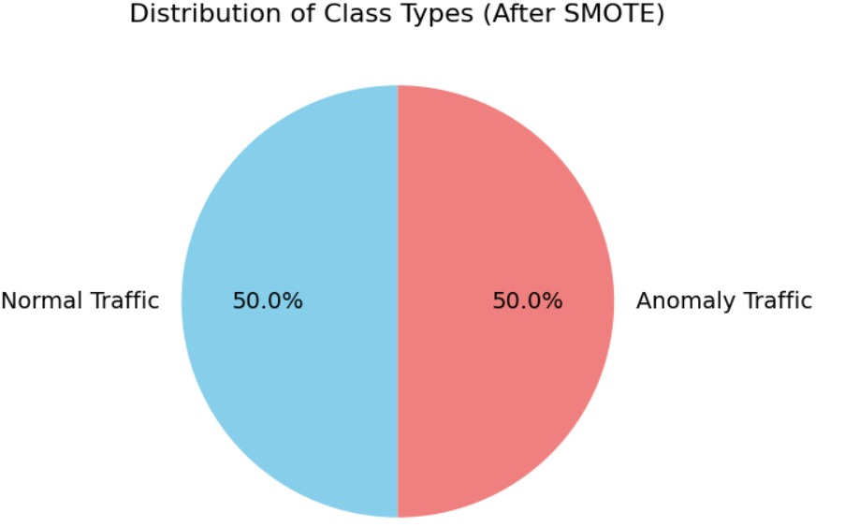
Fig. 5. Balanced data using SMOTE technique

2.3 Convolutional Neural Network (CNN) Architecture
The proposed CNN model is designed to efficiently detect anomalies in network traffic data by leveraging the powerful feature extraction capabilities of convolutional layers. The model begins with multiple 1D convolutional layers, (1), each using 32 filters with a kernel size of 3 and RELU activation function, (2), which helps in capturing local patterns and relationships within the sequential input features of shape (41, 1). Dropout layers, (3) with a rate of 40% are introduced after every two convolutional layers to prevent overfitting and improve model generalization. Furthermore, additional convolutional layers with 64 filters are incorporated to capture more complex patterns. After feature extraction, a Flatten layer is used to convert the multi-dimensional output into a 1D vector, which is then passed to a dense layer with 256 neurons and RELU activation for high-level feature learning. A final dropout layer with a higher rate of 50% further enhances robustness. The output layer consists of two neurons with softmax activation, effectively classifying the input data into two categories: normal or malicious. This refined CNN architecture combines convolutional feature learning with dropout layers, ensuring accurate and efficient anomaly detection. The model summary is shown in Fig.6.

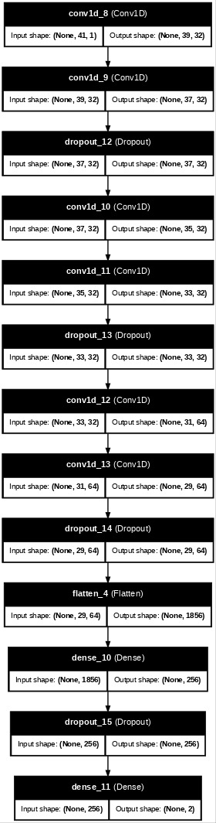
Fig. 6. CNN Model Architecture

Convolutional Layer (Conv1D, 32 Filters, ReLU)
$Z_{1}^{(i)}=\sum_{j=1}^{k}{}W_{1}^{(i)}X^{(i+j)}+b_{1}$………… (1)
where:
- X is the input vector of shape (41,1).
- ​$W_{1 }$is the kernel (weight) matrix of shape (3,1,32).
- k=3 is the kernel size.
- ​ $b_{1}$is the bias vector
- $Z_{1}^{(i)}$is the pre-activation output of the convolution.
- $X^{(i+j)}$ are the input values covered by the filter.
- The filter slides along the time/feature dimension.
The ReLU activation is applied:
$A_{1}^{\left(i\right)}=\left(0,Z_{1}^{\left(i\right)}\right)$ ………… (2)
Where $A_{1}^{\left(i\right)}$ is the activated output.
Dropout Layer (40%)
$A_{2}^{'}=D_{1}⊙A_{2}$ ………… (3)
where:
- ​ $D_{1}$is a binary dropout mask (with probability 0.4 for dropping neurons)
- ⊙ represents element-wise multiplication.
Loss Function (Binary Cross Entropy)
$L=-\sum_{i=1}^{m}{}Y_{i}loglog \left(\hat{Y_{i}}\right)$………… (4)
where:
- ​ $Y_{i}$is the true label (one-hot encoded)
- $\hat{Y_{yi}}$​​ is the predicted probability.
Adam Optimization Update Rule
$W_{t+1}=W_{t}-η⋅\frac{m_{t}}{\sqrt{v_{t}}+ϵ}$………… (5)
where:
- $m_{t}$ and $n_{t}$are the first and second moment estimates,
- η is the learning rate (0.001),
- ϵ prevents division by zero.
2.4 Artificial Neural Network (ANN) Architecture
The proposed ANN model is intended exclusively for binary classification tasks, with a focus on anomaly detection in network traffic data. The model employs a sequential architecture with numerous dense layers and innovative activation functions like Swish, (8) and GELU,(9), which serve to increase non-linear learning capabilities and convergence. The input layer,(6) accepts a feature vector of shape (41, 1), representing extracted network features, and flattens it for processing. To reduce overfitting and ensure robust generalization, three hidden layers of 256, 128, and 64 neurons each are utilized, followed by a 40% dropout layer. The output layer is made up of two neurons that employ a softmax activation function to categorize network data as normal or anomaly. Furthermore, the model is created with the Adam optimizer (5), a learning rate of 0.001, and a binary cross-entropy loss function (4), which enables fast weight updates and accurate classification. The combination of advanced activation functions, dropout layers, and optimized architecture contributes to the model’s high performance, achieving strong accuracy while maintaining computational efficiency. The model summary is shown in Fig.7.
Input Layer Transformation:
$x^{'}=Flatten\left(x\right)$………… (6)
Since the input shape is (41,1), flattening converts it into a vector of size 41.

Hidden Layer (256 Neurons, Swish Activation):
$Z_{1}=W_{1}X^{'}+b_{1}$………… (7)
$A_{1}=Swish\left(Z_{1}\right)=Z_{1}⋅σ\left(Z_{1}\right)=Z_{1}⋅\frac{1}{1+ⅇ^{-Z_{1}}}$………… (8)
where:
- $x$is the input data.
- $x^{'}$is the input vector
- $W_{1 }$is the weight
- ​ $b_{1}$is the bias vector
- $σ\left(Z_{1}\right)$ is the sigmoid function.
Hidden Layer (128 Neurons, GELU Activation):
$A_{2}​=GELU(Z_{2}​) = \frac{1}{2}​ Z_{2}​(1+tanh(\sqrt{\frac{2}{π}}​​(Z_{2}​ ​+ 0.044715Z_{2}^{3}​​)))$... (9)
GELU (Gaussian Error Linear Unit) smooths activation with a probabilistic approach.
where:
- $W_{2 }$is the weight
- ​ $b_{2}$is the bias vector
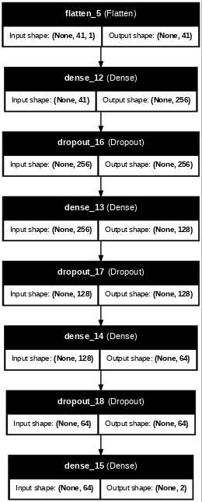

Fig. 7. ANN Model Architecture
2.5 Hybrid Model
Algorithm 1: Anomaly detection using Hybrid Model
1: | Hybrid CNN_ANN ($X_{train}$, $Y_{train}$, $X_{val}$, $Y_{val}$)
2: | Input: Dataset ($X_{train}$, $Y_{train}$, $X_{val}$, $Y_{val}$)
3: | Output: Performance metrics
4: | Define Hybrid CNN-ANN architecture:
5: | CNN branch: set Conv1D layers, flatten, dense, and dropout layers
6: | ANN branch: set Flatten, dense layers, and dropout layers
7: | Concatenate CNN and ANN branches
8: | Add fully connected layers with dense, and dropout layers
9: | Compile the Hybrid CNN-ANN model
10: | Set the batch size, optimizer, learning rate, epoch count (n), and early stopping criteria to their initial values.
11: | for i in 1 to n do
12: | Train Hybrid CNN-ANN model using $X_{train}$, $Y_{train}$
13: | end while
14: | Evaluate the Hybrid CNN-ANN model using $X_{val}$, $Y_{val}$and calculate evaluation metrics
15: | Return the calculated metrics

The proposed hybrid model integrates both (CNN) and ANN architectures to enhance the accuracy and efficiency of anomaly detection in network traffic data. The model consists of two parallel branches: the CNN branch extracts local and spatial features using multiple Conv1D layers with GELU activation, followed by MaxPooling1D and dropout layers to reduce overfitting. The ANN branch, on the other hand, flattens the input features and passes them through several dense layers with GELU activations and dropout layers, focusing on learning complex patterns and relationships in the data. After independent feature extraction, both branches are concatenated, allowing the model to utilize the strengths of both architectures—CNN's ability to capture spatial dependencies and ANN's capacity for high-level feature abstraction. The combined output is processed through fully connected layers with dropout layers and ends with a softmax-activated output layer for binary classification. The model is compiled using the Adam optimizer and binary cross-entropy loss function, ensuring effective learning. By combining CNN and ANN branches, this hybrid model achieves superior performance in identifying anomalies while maintaining robustness against overfitting. The hybrid model summary is shown in Fig.8 and Algorithm 1 explains the operational flow of the proposed hybrid CNN-ANN model.

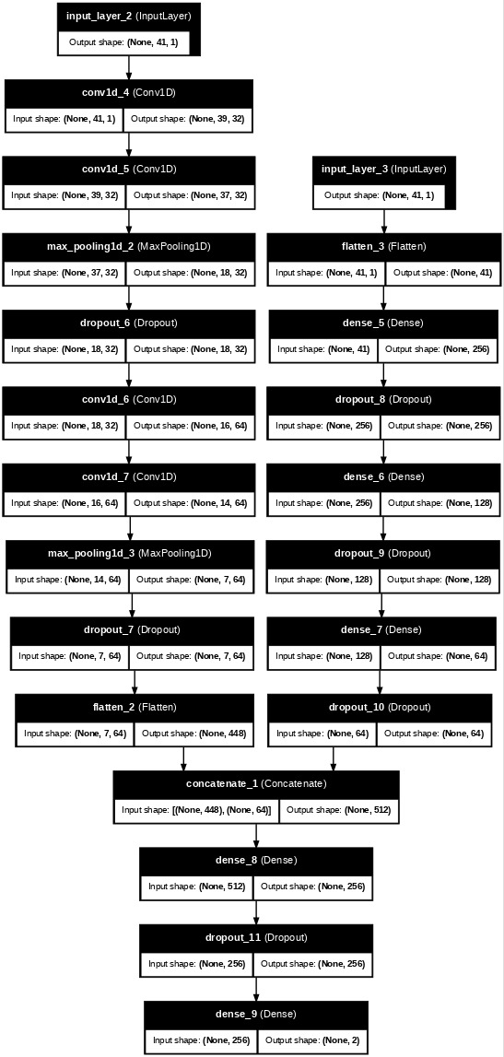
Fig. 8. Hybrid CNN-ANN Model Architecture

2.6 Performance Metrics
The confusion matrix serves as the foundation for multiple performance metrics that assess
the model's effectiveness across different classification challenges:
• Accuracy: Measures the overall proportion of correct predictions among all
predictions. However, accuracy alone can be misleading in cases of imbalanced
datasets. Accuracy = (True Positives + True Negatives) / (True Positives + True Negatives + False Positives + False Negatives)
• Precision: Defined as TP / (TP + FP), precision calculates how many of the
predicted positive cases are actually correct. It is particularly useful in scenarios
where false positives must be minimized, such as fraud detection.
• Recall (Sensitivity or True Positive Rate): Given by TP / (TP + FN), recall
evaluates how well the model identifies actual positive cases. It is crucial in cases
where missing positive instances could have severe consequences, such as in
medical diagnoses.
• F1-Score: A harmonic mean of precision and recall, the F1-score balances both
metrics, making it ideal for scenarios where both false positives and false negatives
are critical. F1 = 2 * (Precision * Recall) / (Precision + Recall)
3. Results and Discussion
For all our models we tried different epoch sizes i.e. 20, 40 and 60, and among those, 40 epochs showed better fit. Table. 3 shows the accuracy, loss, validation accuracy, and validation loss evaluation of the proposed models for 40 epochs from the dataset: Network Intrusion Detection [26]. We ran all our models on the same device having Intel core i5 processor with 8 cores and NVIDIA GeForce GTX 6090. The CNN model demonstrated 94.36% accuracy with 95.53% validation accuracy although it resulted in higher validation loss. The ANN delivered marginal higher accuracy of 96.82% but showed a 94.63% validation accuracy which indicates an overfitting problem. The hybrid model delivered superior performance with 98.34% accuracy and 97.65% validation accuracy compared to standalone models due to its better learning ability. The higher model complexity in this system seems to lead to a 4.58% training loss quantity.

Table 3. Comparison of Results of CNN, ANN and Hybrid CNN-ANN models
Model | Accuracy | Loss | Val-accuracy | Normal |  |  | Anomaly
 |  |  |  | Precision | Recall | F1-score | Precision | Recall | F1-score
CNN | 94.36% | 2.009% | 95.53% | 92% | 94% | 93% | 95% | 93% | 94%
ANN | 96.82% | 2.2037% | 94.63% | 98% | 93% | 96% | 94% | 95% | 97%
Hybrid | 97.65% | 2.6534% | 98.34% | 100% | 95% | 97% | 96% | 100% | 98%

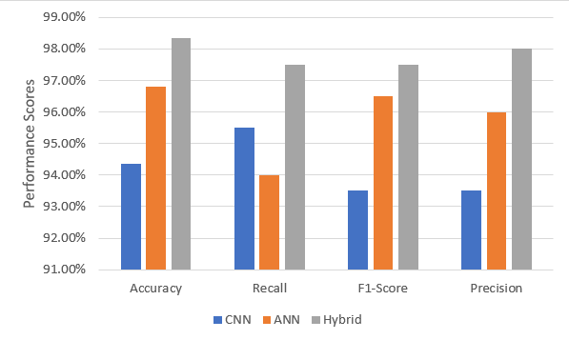
Fig. 9. Comparison of Performance Parameters

Also, Table. 3 and Fig.9 shows the performance analysis of CNN, ANN, and Hybrid models through performance metrics measurements for Normal and Anomaly detection. The CNN model shows precision of 92%, recall of 94% and F1-score of 93% for normal class and 95%, 93% and 94% respectively for anomaly class. ANN demonstrates precision of 98%, recall of 93% and F1-score of 94% for normal class and 94%, 95% and 97% respectively for anomaly class. The Hybrid model surpasses both previous models with its precision reaching 100%, 95% of recall and 97% of F1-score for normal instances while achieving 96% precision, 100% of recall and 98% of F1-score for anomalies.
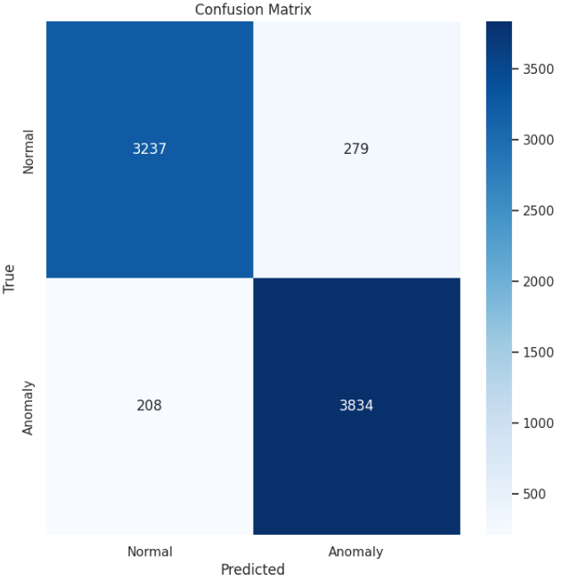
Fig. 10. Confusion Matrix

The confusion matrix evaluates how well a classification model diagnoses Normal and Anomaly cases. Where the model successfully detected Normal cases among a total of 6661 instances it obtained 3,237 True Positive results while achieving 3,834 True Negative results. Two hundred seventy-nine legitimate Normal cases were mistakenly identified as Anomalies while two hundred eight actual cases of Anomalies were mistakenly classified as Normal. The model presents good overall performance through its numerous correct classifications yet displays several misclassifications shown through its false positive and false negative values.

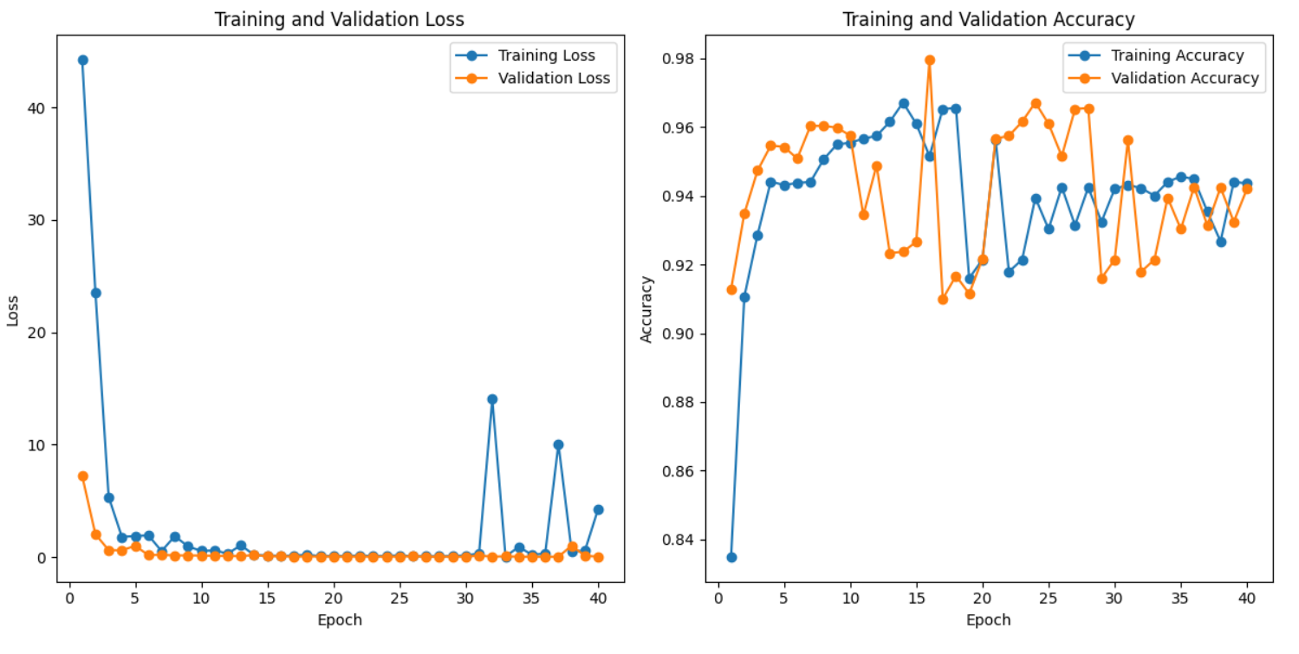
Fig. 11. Performance of CNN

Fig.11 shows the accuracy of CNN model with validation accuracy as red which is 95.53% and training accuracy as blue which is 94.36% and also shows the loss of the CNN model with validation loss as red which is 3.37% and training loss as blue which is 2.009% across 40 epochs. 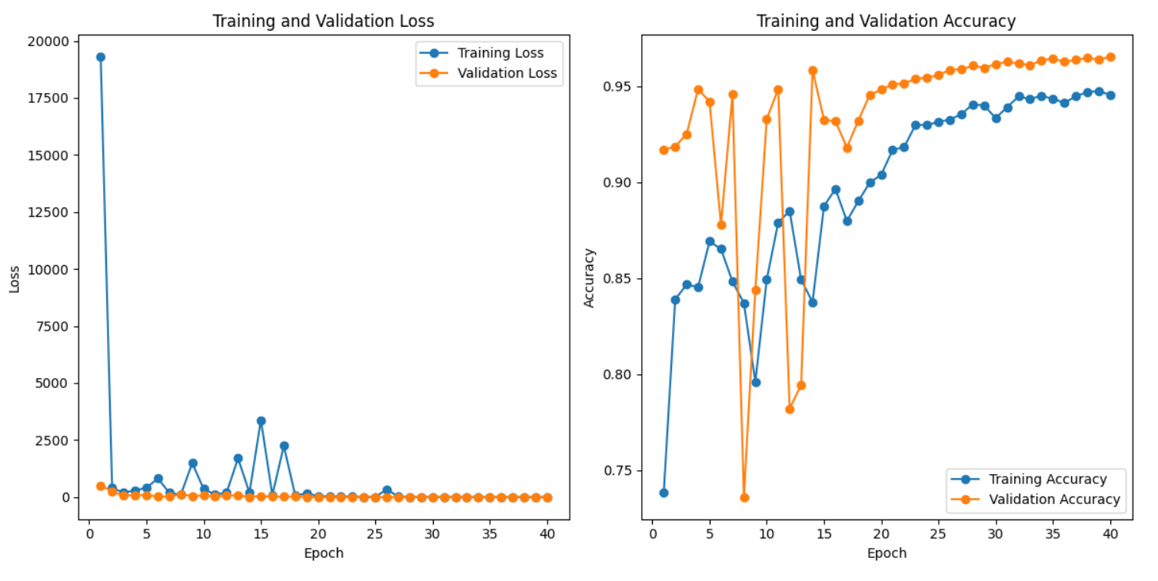
Fig. 12. Performance of ANN

Fig.12 shows the accuracy of ANN model with validation accuracy as red which is 94.63% and training accuracy as blue which is 96.82% and also shows the loss of the ANN model with validation loss as red which is 11.85% and training loss as blue which is 2.2037% across 40 epochs.
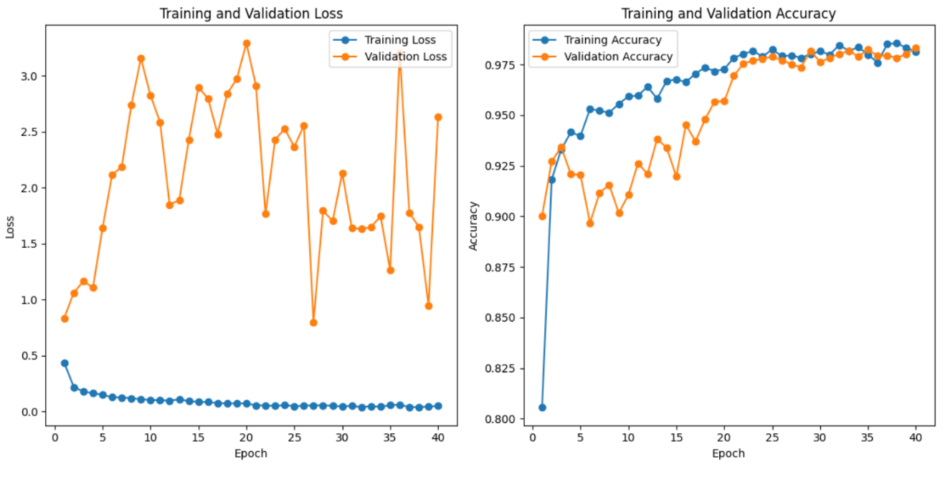
Fig. 13 Performance of Hybrid Model
Fig.13 shows the accuracy of the hybrid model with validation accuracy as red which is 98.34% and training accuracy as blue which is 97.65% and also shows loss of the hybrid model with validation loss as red which is 98.34% and training loss as blue which is 2.534% across 40 epochs. The authors Behdadnia, T., et al in [3] used CNN model which achieved 93% accuracy, and the authors in Zhu, Z., et al [11] also used CNN model which shows signs of overfitting as it is achieving 100% accuracy, and the authors in Bakhshi, T., et al [17] used a hybrid of CNN+GRU(Gated Recurrent Unit) which achieved 93.10% accuracy, comparative with all these researches our proposed hybrid model of CNN+ANN shows more efficiency, reduces overfitting and increased performance as shown in Fig.14. The training accuracy shows rapid growth starting from zero up to approximately 98.34% before experiencing both small improvements and small declines. The validation accuracy levels stay stable at 97.65% after exceeding 95% with negligible ups and downs. The model demonstrates strong performance in test data although training accuracy fails to match it which might result from the model achieving widespread generalization as opposed to overfitting.
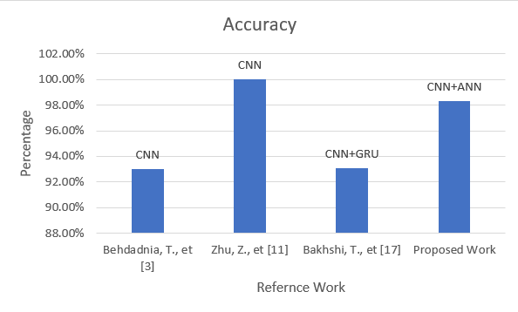
Fig. 14. Comparison of Proposed work with existing studies
4. Conclusion
The proposed hybrid model of the ANN and CNN system achieves higher accuracy and shows much more promising results for anomaly detection in encryption traffic. The data preprocessing module assures that no null values existed and we performed label encoding to change categorical data to numerical data. To remove class imbalance and balance the dataset we used SMOTE technique. The ANN and CNN architectures were refined with added hidden layers to increase the efficiency, and we used ReLU and GeLU activation functions to update weights for better performance. We also used Adam and RMSprop optimizers for the model to learn more effectively. Both of the models did give very good results with 96.82% and 94.36% accuracy respectively, but for more compelling and promising outputs we combined them both into a hybrid model, which gave us excellent results with 98.34% accuracy. Comparatively the hybrid model is more promising, efficient and effective than refined ANN and CNN architectures. The proposed hybrid model also achieved higher precision of 98%, recall of 96.5% and F1-score of 97.5%.

References
- Z. Wu, H. Li, Y. Qian, Y. Hua and H. Gan, "Poison-Resilient Anomaly Detection: Mitigating Poisoning Attacks in Semi-Supervised Encrypted Traffic Anomaly Detection," in IEEE Transactions on Network Science and Engineering, vol. 11, no. 5, pp. 4744-4757, Sept.-Oct. 2024, http://doi.org/doi: 10.1109/TNSE.2024.3397719.
- J. Xing and C. Wu, "Detecting Anomalies in Encrypted Traffic via Deep Dictionary Learning," IEEE INFOCOM 2020 - IEEE Conference on Computer Communications Workshops (INFOCOM WKSHPS), Toronto, ON, Canada, 2020, pp. 734-739, http://doi.org/doi: 10.1109/INFOCOMWKSHPS50562.2020.9162940
- T. Behdadnia, G. Deconinck, C. Ozkan and D. Singelee, "Encrypted Traffic Classification for Early-Stage Anomaly Detection in Power Grid Communication Network," 2023 IEEE PES Innovative Smart Grid Technologies Europe (ISGT EUROPE), Grenoble, France, 2023, pp. 1-6, http://doi.org/doi: 10.1109/ISGTEUROPE56780.2023.10407155
- T. Yu, F. Zou, L. Li and P. Yi, "An Encrypted Malicious Traffic Detection System Based on Neural Network," 2019 International Conference on Cyber-Enabled Distributed Computing and Knowledge Discovery (CyberC), Guilin, China, 2019, pp. 62-70, http://doi.org/doi: 10.1109/CyberC.2019.00020
- G. Lv, R. Yang, Y. Wang and Z. Tang, "Network Encrypted Traffic Classification Based on Secondary Voting Enhanced Random Forest," 2020 IEEE 3rd International Conference on Computer and Communication Engineering Technology (CCET), Beijing, China, 2020, pp. 60-66, http://doi.org/doi: 10.1109/CCET50901.2020.9213165
- M. Kopp, M. Grill and J. Kohout, "Community-based anomaly detection," 2018 IEEE International Workshop on Information Forensics and Security (WIFS), Hong Kong, China, 2018, pp. 1-6, http://doi.org/doi: 10.1109/WIFS.2018.8630772
- S. Han, Q. Wu, H. Zhang and B. Qin, "Light-weight Unsupervised Anomaly Detection for Encrypted Malware Traffic," 2022 7th IEEE International Conference on Data Science in Cyberspace (DSC), Guilin, China, 2022, pp. 206-213, http://doi.org/doi: 10.1109/DSC55868.2022.00034
- M. Shen et al., "Machine Learning-Powered Encrypted Network Traffic Analysis: A Comprehensive Survey," in IEEE Communications Surveys & Tutorials, vol. 25, no. 1, pp. 791-824, First quarter 2023, http://doi.org/doi: 10.1109/COMST.2022.3208196
- F. Meghdouri, F. I. Vázquez and T. Zseby, "Cross-Layer Profiling of Encrypted Network Data for Anomaly Detection," 2020 IEEE 7th International Conference on Data Science and Advanced Analytics (DSAA), Sydney, NSW, Australia, 2020, pp. 469-478, http://doi.org/doi: 10.1109/DSAA49011.2020.00061
- Z. Wang, P. Wang and Z. Sun, "SDN traffic anomaly detection method based on convolutional autoencoder and federated learning," GLOBECOM 2022 - 2022 IEEE Global Communications Conference, Rio de Janeiro, Brazil, 2022, pp. 4154-4160, http://doi.org/doi: 10.1109/GLOBECOM48099.2022.10001438
- Z. Zhu, H. Zhou, Q. Yang, C. Wang and Z. Li, "Anomaly Detection in Encrypted Identity Resolution Traffic based on Machine Learning," 2022 IEEE 22nd International Conference on Software Quality, Reliability and Security (QRS), Guangzhou, China, 2022, pp. 264-275, http://doi.org/doi: 10.1109/QRS57517.2022.00036
- D. Ucci, F. Sobrero, F. Bisio and M. Zorzino, "Near-real-time Anomaly Detection in Encrypted Traffic using Machine Learning Techniques," 2021 IEEE Symposium Series on Computational Intelligence (SSCI), Orlando, FL, USA, 2021, pp. 01-08, http://doi.org/doi: 10.1109/SSCI50451.2021.9659955
- Kim, M. G., & Kim, H. “ Anomaly Detection in Imbalanced Encrypted Traffic with Few Packet Metadata-Based Feature Extraction”, Computer Modeling in Engineering & Sciences (CMES), Vol 141, Issue 1, p585, 2024, http://doi.org/doi:10.32604/cmes.2024.051221
- J. Ashraf, A. D. Bakhshi, N. Moustafa, H. Khurshid, A. Javed and A. Beheshti, "Novel Deep Learning-Enabled LSTM Autoencoder Architecture for Discovering Anomalous Events From Intelligent Transportation Systems," in IEEE Transactions on Intelligent Transportation Systems, vol. 22, no. 7, pp. 4507-4518, July 2021, http://doi.org/doi:10.1109/TITS.2020.3017882
- Long, Gang, and Zhaoxin Zhang. "Deep encrypted traffic detection: An anomaly detection framework for encryption traffic based on parallel automatic feature extraction." Computational Intelligence and Neuroscience Vol. 2023, no. 1, https://doi.org/10.1155/2023/3316642
- M. Pratiwi and Y. -H. Choi, "Context-Aware Anomaly-based Detection for Ransomware using Multivariate Feature," 2024 IEEE Conference on Communications and Network Security (CNS), Taipei, Taiwan, 2024, pp. 1-9, https://doi.org/doi: 10.1109/CNS62487.2024.10735651
- Tian, Zhiyi, Lei Cui, Jie Liang, and Shui Yu. "A comprehensive survey on poisoning attacks and countermeasures in machine learning." ACM Computing Surveys 55, no. 8, pp. 1-35, 2022, https://doi.org/10.1145/3551636
- Anderson, Blake, and David McGrew. "Identifying encrypted malware traffic with contextual flow data." In Proceedings of the 2016 ACM workshop on artificial intelligence and security, pp. 35-46. 2016, https://doi.org/10.1145/2996758.2996768
- Anish Singh Shekhawat, Fabio Di Troia, Mark Stamp, “Feature analysis of encrypted malicious traffic”, Expert Systems with Applications, Vol.125, pp. 130-141, 2019, https://doi.org/10.1016/j.eswa.2019.01.064
- Velan, P., Čermák, M., Čeleda, P. and Drašar, M., “A survey of methods for encrypted traffic classification and analysis”, International Journal of Network Management, vol. 25, isuue.5, pp.355-374, https://doi.org/10.1002/nem.1901
- S. Rezaei and X. Liu, "Deep Learning for Encrypted Traffic Classification: An Overview," in IEEE Communications Magazine, vol. 57, no. 5, pp. 76-81, May 2019, https://doi.org/doi: 10.1109/MCOM.2019.1800819
- J. Wang, T. He, G. He, H. Zhu, B. Xu and L. Zhang, "Cooperative Detection of Camouflaged Malicious TLS Traffic," 2023 Eleventh International Conference on Advanced Cloud and Big Data (CBD), Danzhou, China, 2023, pp. 116-121, https://doi.org/doi: 10.1109/CBD63341.2023.00029
- T. Wingarz, A. See, F. Gondesen and M. Fischer, "Privacy-preserving Network Anomaly Detection on Homomorphically Encrypted Data," 2024 IEEE Conference on Communications and Network Security (CNS), Taipei, Taiwan, 2024, pp. 1-9, https://doi.org/doi: 10.1109/CNS62487.2024.10735601
- Bakhshi, Taimur, and Bogdan Ghita. "Anomaly detection in encrypted internet traffic using hybrid deep learning." Security and Communication Networks, Vol. 2021, no. 1 Article ID. 5363750, https://doi.org/10.1155/2021/5363750
- I. Lee, H. Roh and W. Lee, "Poster Abstract: Encrypted Malware Traffic Detection Using Incremental Learning," IEEE INFOCOM 2020 - IEEE Conference on Computer Communications Workshops (INFOCOM WKSHPS), Toronto, ON, Canada, 2020, pp. 1348-1349, https://doi.org/doi: 10.1109/INFOCOMWKSHPS50562.2020.9162971
- https://www.kaggle.com/datasets/sampadab17/network-intrusion-detection (Link for the dataset)
- Baldoni, S., & Battisti, F. (2025). Histogram-based network traffic representation for anomaly detection through PCA. Computer Networks, 111276, https://doi.org/10.1016/j.comnet.2025.111276
- Nwatuzie, G., & Peyravi, H. (2025). DRNMS: An Enhanced Deep Learning-Based System for Data Recovery and Anomaly Detection in Network Monitoring. In International Conference on Computational Science and Computational Intelligence (pp. 87-103). Springer, Cham,.https://doi.org/10.1007/978-3-031-90341-0_7
- Ness, S., Eswarakrishnan, V., Sridharan, H., Shinde, V., Janapareddy, N. V. P., & Dhanawat, V. (2025). Anomaly Detection in Network Traffic using Advanced Machine Learning Techniques. IEEE Access, https://doi.org/10.1109/ACCESS.2025.3526988
- Gassaloglu, Y. Anomaly Detection in Network Traffic Using Machine Learning for Next-Generation Firewalls. http://dx.doi.org/10.13140/RG.2.2.30870.46404
- Khan, M. M., Rehman, M. Z., Khan, A., & Abusham, E. (2024). Anomaly detection in network traffic with ELSC learning algorithm. Electronics Letters, 60(14), e13235.,https://doi.org/10.1049/ell2.13235
- Ji, C., Liu, H., & Dai, W. (2025). Hybrid Model for Network Traffic Anomaly Detection Based on Parallel Two-stage Feature Fusion. IEEE Access.https://doi.org/10.1109/ACCESS.2025.3538319
- Rao, V. S., Balakrishna, R., El-Ebiary, Y. B., Thapar, P., Saravanan, K. A., & Godla, S. R. (2024). Ai driven anomaly detection in network traffic using hybrid cnn-gan. Journal of Advances in Information Technology, 15(7), 886-895.https://doi.org/10.12720/jait.15.7.886-895
- PM, V. P., & Soumya, S. (2024). Advancements in Anomaly Detection Techniques in Network Traffic: The Role of Artificial Intelligence and Machine Learning. Journal of Scientific Research and Technology, 38-48.https://doi.org/10.61808/jsrt114
- Koumar, J., Hynek, K., Čejka, T., & Šiška, P. (2025). CESNET-TimeSeries24: Time Series Dataset for Network Traffic Anomaly Detection and Forecasting. Scientific Data, 12(1), 338. https://doi.org/10.1038/s41597-025-04603-x
- Liu, D., Wang, S., YutongLi, Du, J., & Li, J. (2025). Research on new energy power plant network traffic anomaly detection method based on EMD. Energy Informatics, 8(1), 14.
https://doi.org/10.1186/s42162-025-00474-z

